**Name :** Shraddha Rajkumar Kotwar

**Class :** TE ( Comp ) - B

**Roll No.:** 18

**Assignment 10 :**

Design and develop custom Application (Mini Project :Example like:Library management system) using Sales force Cloud

**Step 1:** Login in to your developers salesforce account

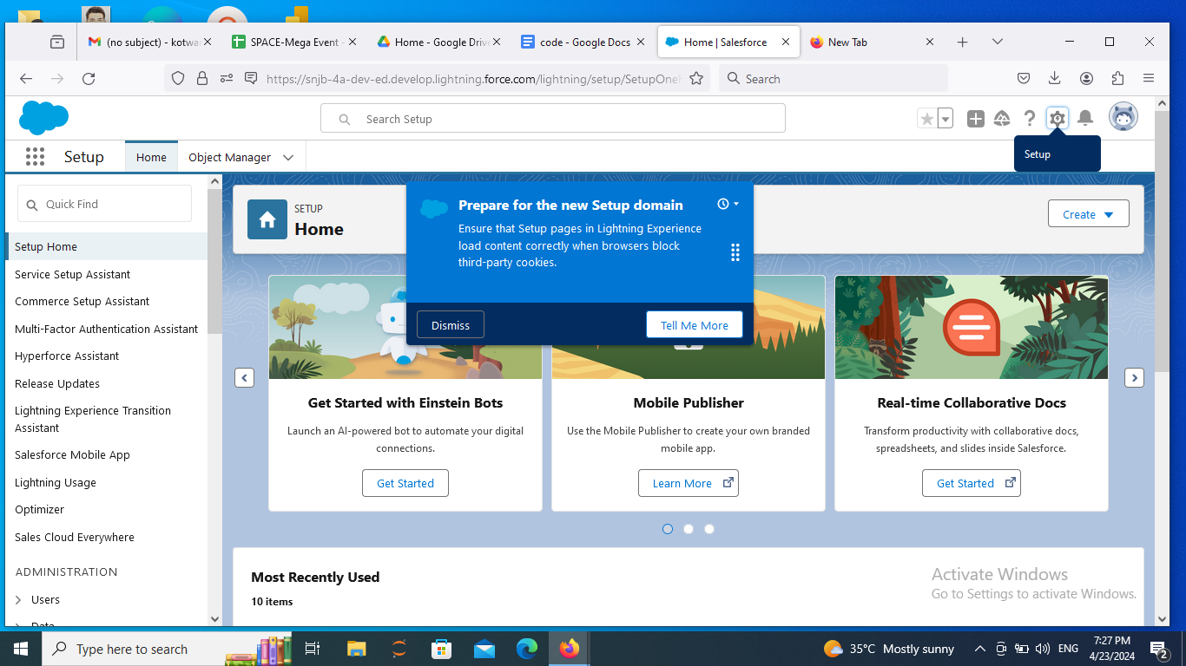

**Step 2:** Go to Object Manager -> Create -> Custom Object

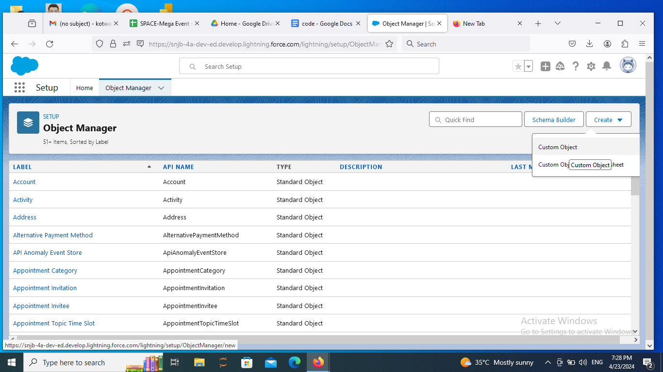

**Step 3:** Create object i.e, table add label name, description and click on save & next.

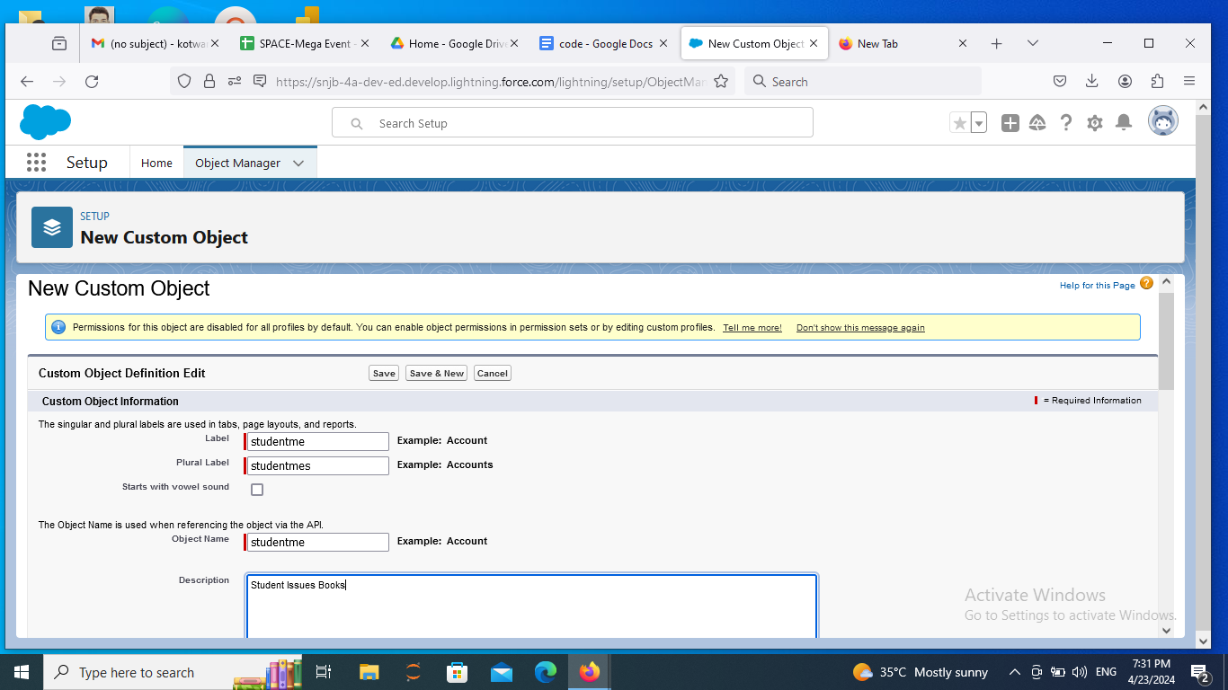

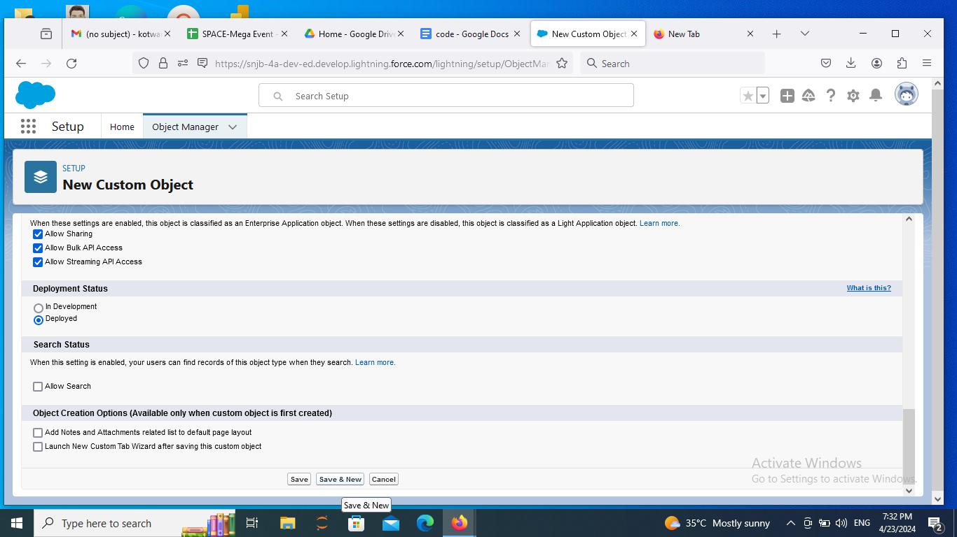

**Step 4:** Similarly create new object i.e, table add label name as book, description and click on save & next

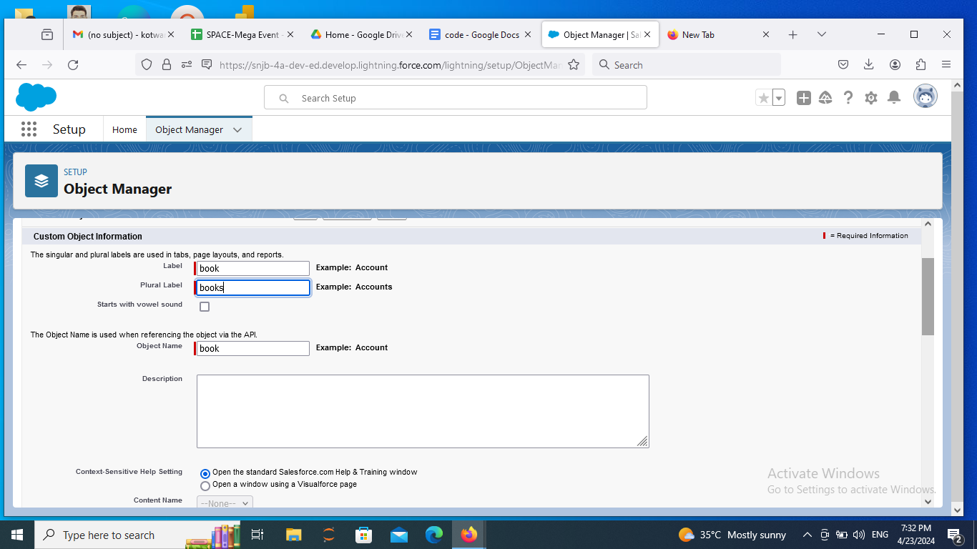

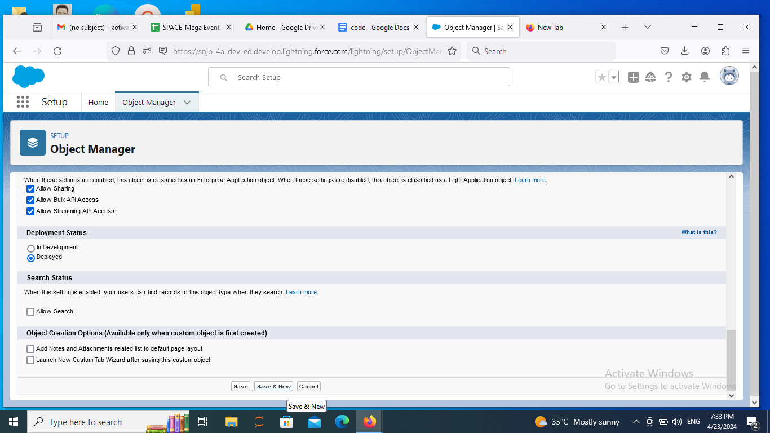

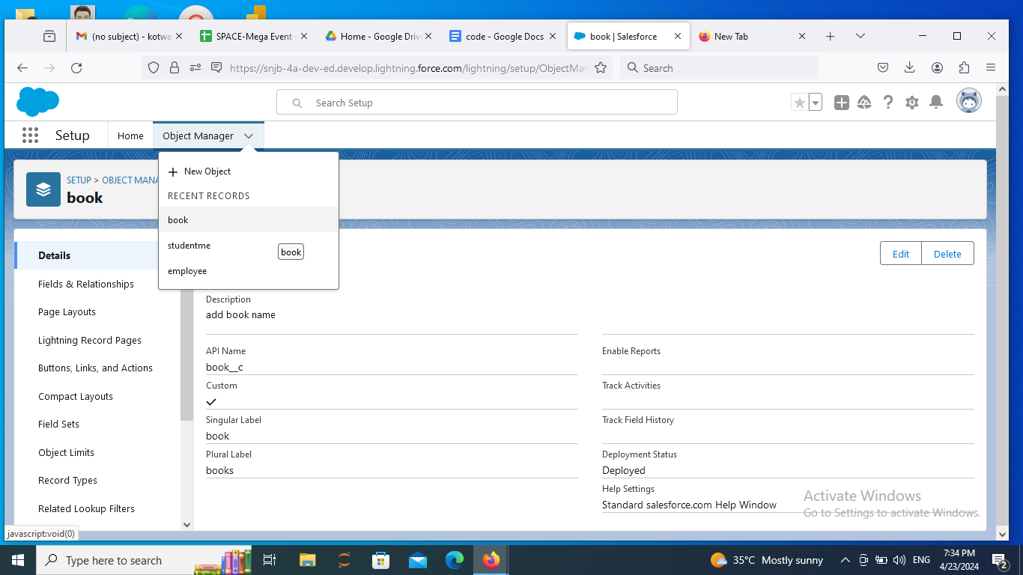

**Step 5:** Select fields and relationship -> New-> Select field type -> next->Add details-> next->save and next

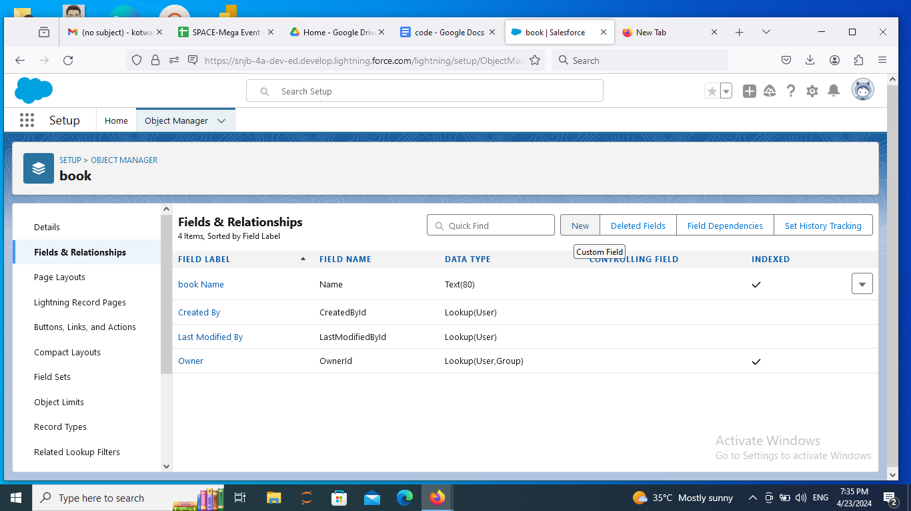

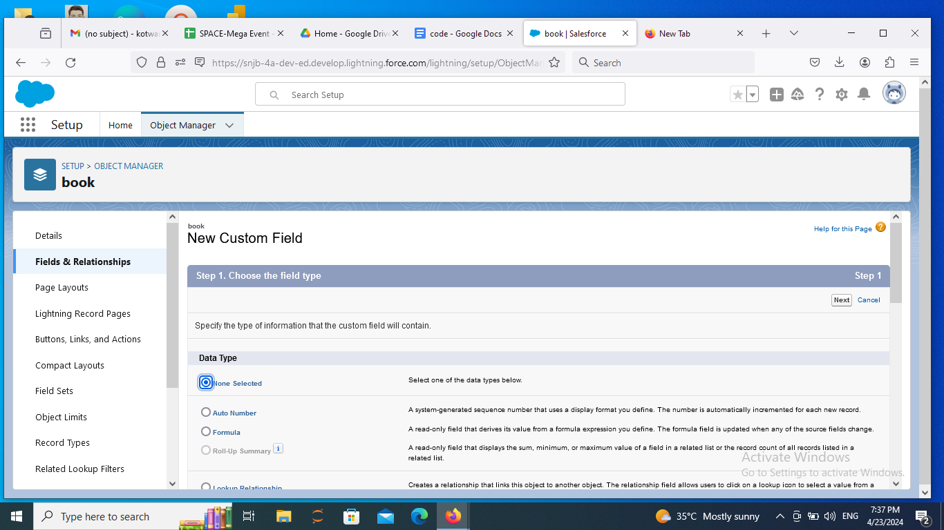

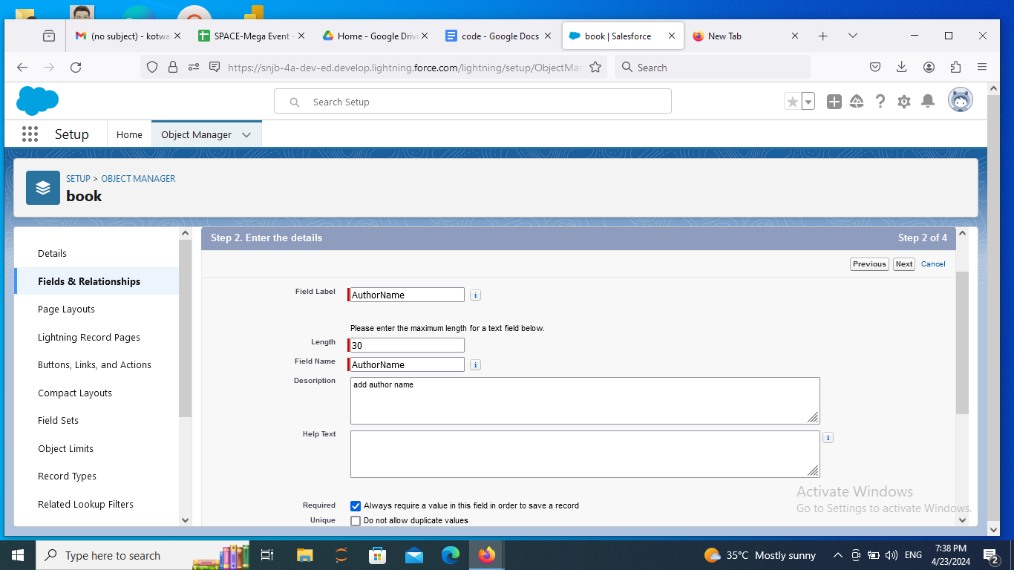

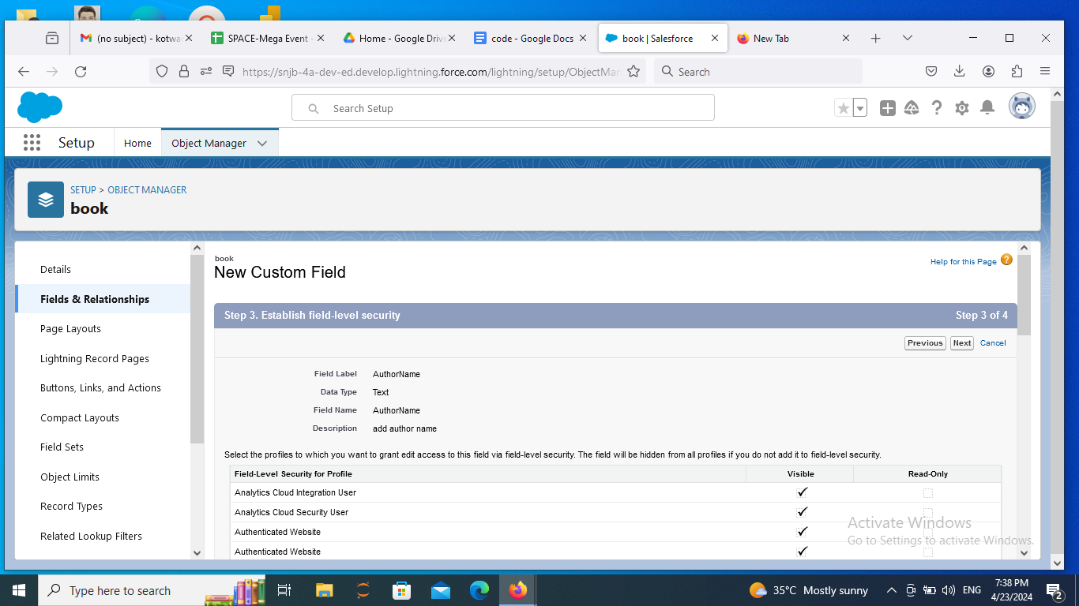

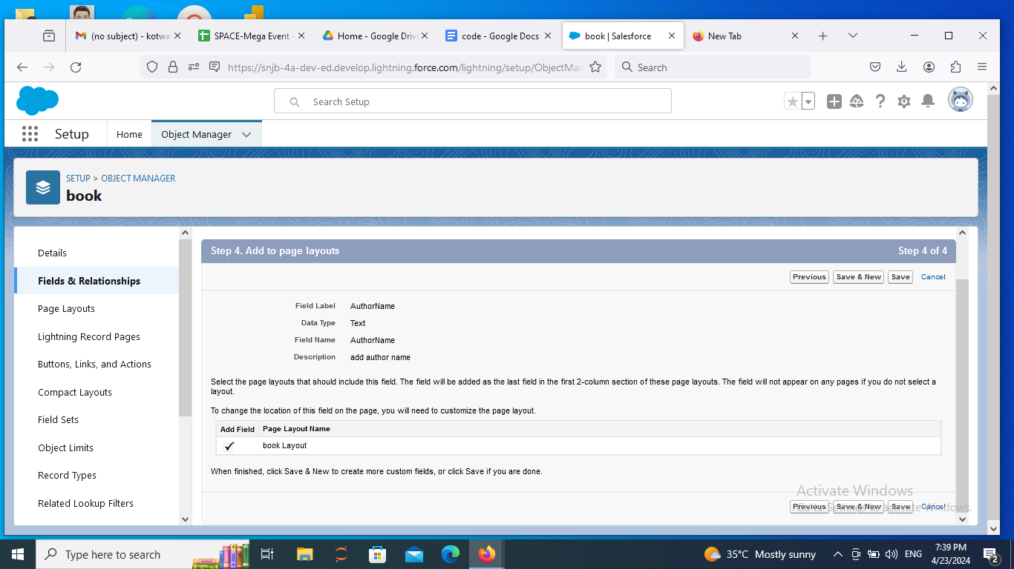

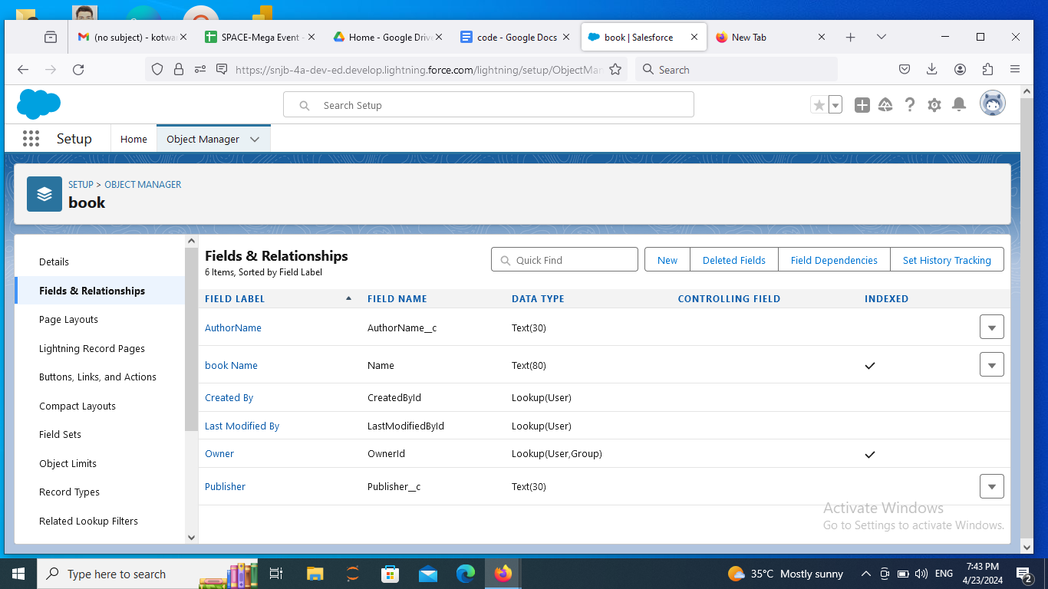

**Step 6:** Click on setup ->Search tabs ->Add custom tab for objects

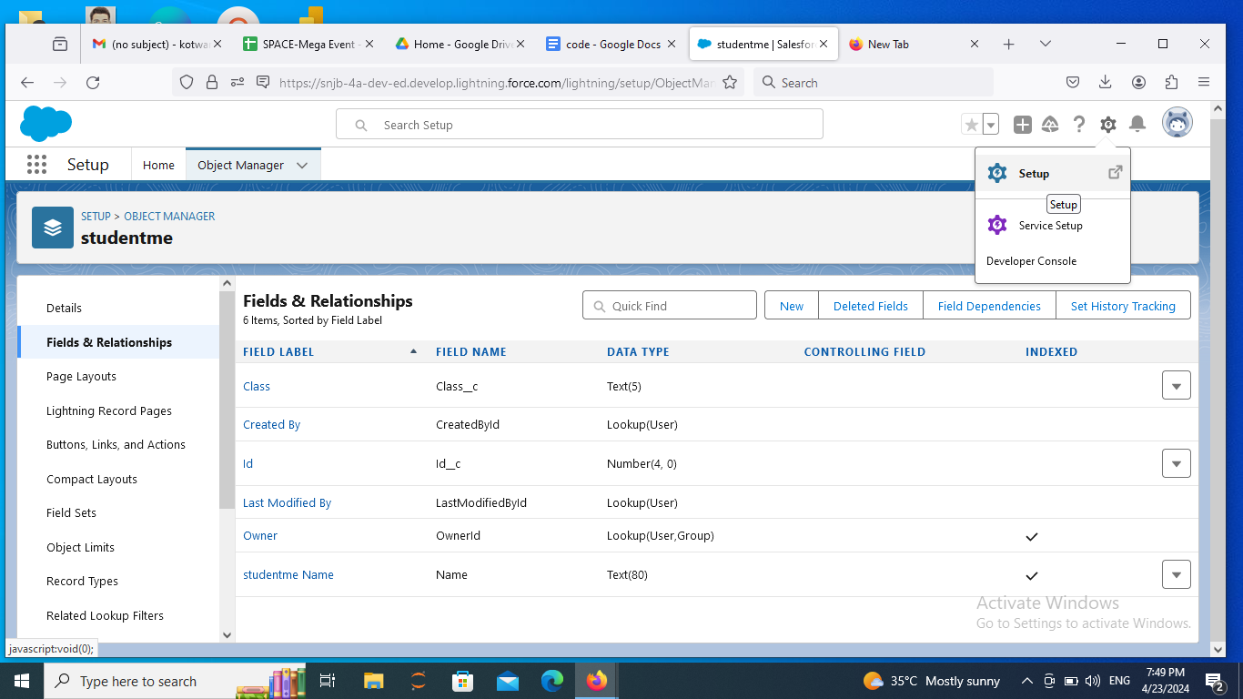

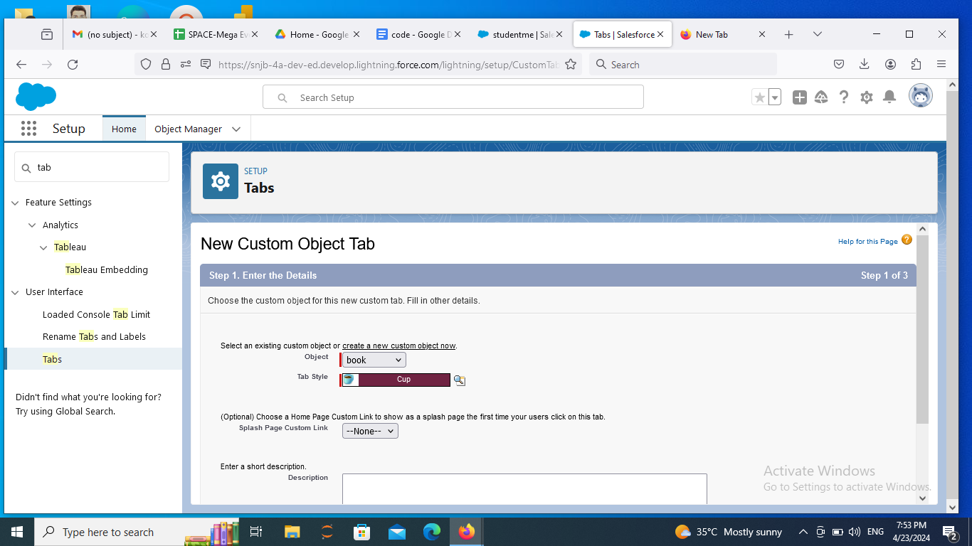

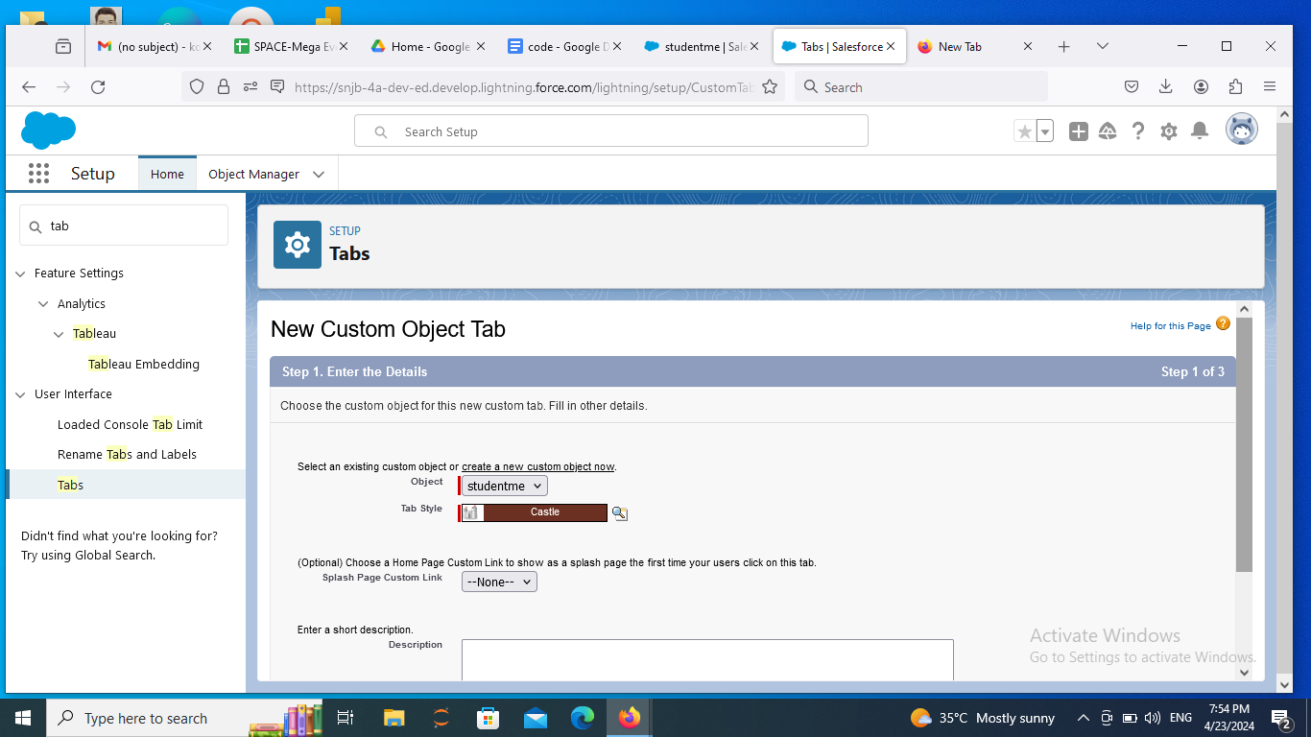

**Step 7:** Click on setup ->Search app -> App manager -> New Lightning App-> Add App name -> next-> Available Profile select System Administrator -> save and finish

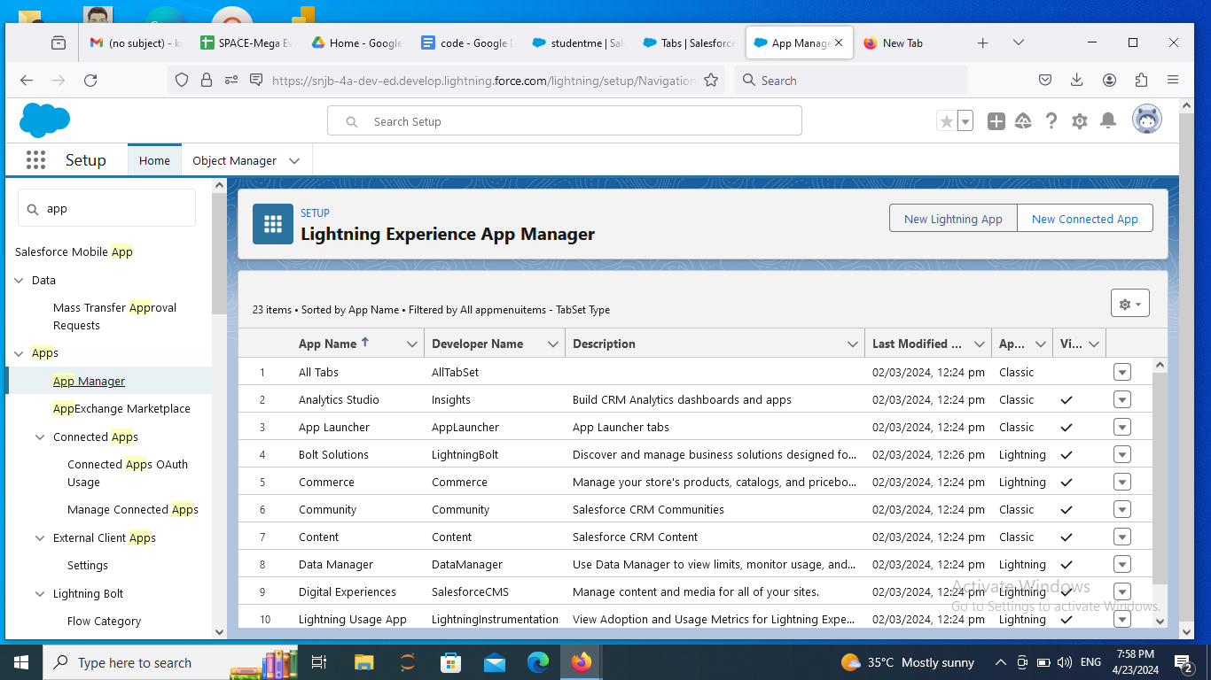

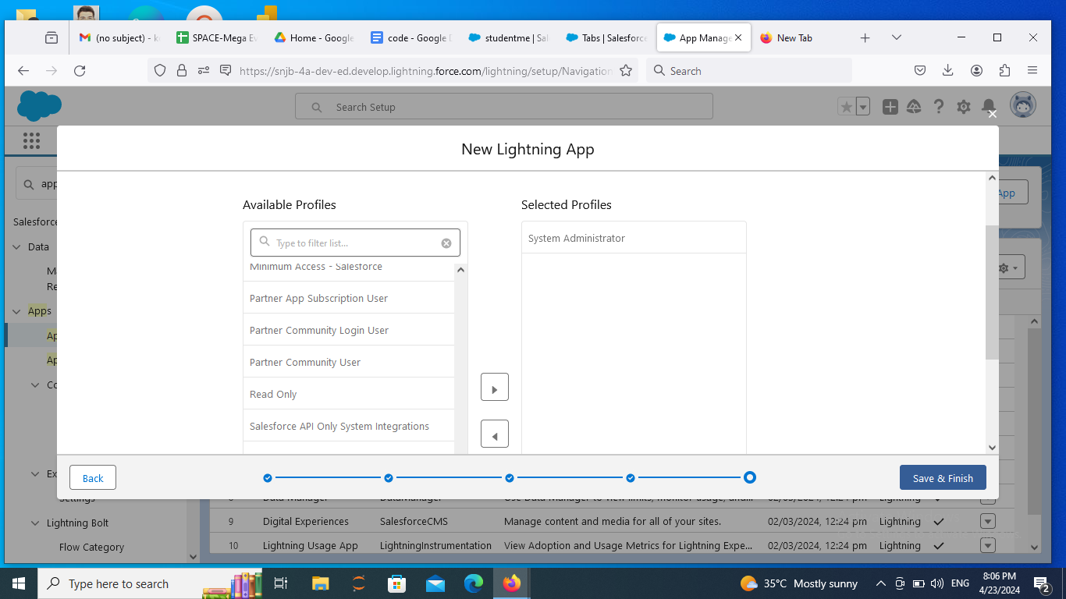

**Step 8:** Click on App Launcher -> Search Library System-> Add records

